**Department of Collegiate & Technical Education**

**Capstone Project**

**Continuous Internal Evaluation – CIE – II**

**Capstone Project Name:** INVENTORY MANAGEMENT SYSTEM

**Capstone Project Members:** SHESHAGIRI S (149CS21046)

DIVYA J (149CS21021)

DILEEP G P (149CS21020)

DHANAYSHREE A P (149CS21061)

**Capstone project Details**

**1.Description of Technology Used :**

* **Front-End:**
* **HTML, CSS, JavaScript:**
  + - **HTML:** Forms the basic structure of the user interface.
    - **CSS:** Styles the UI for optimal user experience and responsiveness.
    - **JavaScript:** Handles basic interactivity and client-side validation.
* **Back-End:**
* **Programming Language:**
  + - **PHP:** Version 7.4 or later is recommended for security and performance improvements. Consider using a framework like Laravel, Symfony, or CodeIgniter for rapid development, code organization, and built-in functionalities.
* **Database:**
  + - **MySQL:** A widely used, open-source relational database suitable for most inventory management needs.
* **Web Framework:**
  + - **Laravel :** These frameworks provide pre-built functionalities like routing, security, and database interactions, speeding up development and promoting code organization.
* **Security:**
  + **Secure coding practices:** Employ input validation, output sanitization, and secure coding principles to prevent vulnerabilities like SQL injection and cross-site scripting (XSS).
  + **Password hashing:** Use robust hashing algorithms like encrypt or Argon2 to store passwords securely.
  + **Role-based access control (RBAC):** Implement RBAC to restrict user access based on permissions and roles, ensuring data security and compliance.

**2. Details of Hardware devices:**

* **Computer or laptop:** A standard computer or laptop with a modern processor, at least 8GB of RAM, and a decent graphics card should be sufficient for most sales forecasting projects. A faster processor and more RAM may be required for more complex projects that involve large datasets or machine learning algorithms.
* **External hard drive:** Depending on the size of the data being used for the sales forecasting project, an external hard drive may be useful for storing and backing up data. This can help free up space on the computer or laptop and prevent data loss in case of hardware failure.
* **Monitor:** A larger monitor or a second monitor can be useful for data visualization and analysis. This can help students to view and compare data more easily, and can increase productivity by allowing multiple windows to be open at the same time.
* **Keyboard and mouse:** A standard keyboard and mouse are essential for data entry and navigation. Students may prefer to use ergonomic keyboards or gaming mice with customizable buttons for increased comfort and efficiency.
* **Printer:** A printer can be useful for printing out reports and visualizations of the sales forecasting project. This can help students to present their findings in a more professional manner.
* **Computer:** You will need a computer with a modern processor, at least 8GB of RAM, and sufficient storage space for your data and software. A laptop or desktop computer should be sufficient for most student-level projects.

**The minimum requirements for the computer are:**

o Operating System: Windows, Mac, or Linux

o Processor: Intel Core i5 or equivalent

o RAM: 8 GB or more

o Hard Disk Space: At least 256 GB

* **Display:** A large display can help you view your data and results more easily. A monitor with a resolution of at least 1080p is recommended.
* **Internet Connection:** An internet connection is necessary to access online resources, libraries, and datasets. A reliable and fast internet connection is recommended for downloading and uploading large datasets.
* **External Hard Drive:** An external hard drive can be used to store and backup your data. This can help you avoid data loss and ensure that you have a copy of your data in case of a computer failure.
* **Optional: GPU:** A GPU can be used to speed up certain calculations and models, especially those that involve large datasets or deep learning algorithms. However, a GPU is not necessary for most student-level sales forecasting projects.

**3. Details of software products :**

* **Microsoft Excel:** Excel is a widely used spreadsheet software that is ideal for performing basic sales forecasting analysis. Excel offers several built-in features and functions that allow students to perform simple statistical calculations, generate charts and graphs, and build basic forecasting models.
* **XAMPP,** an acronym for XApache, **M**ySQL, **A**pache **P**HP and **P**erl, is a free and open-source web server stack bundled with popular software like Apache, MySQL database, PHP script interpreter, and Perl. This makes it a convenient and portable platform for developing and testing web applications, including inventory management systems (IMS).
* **Adobe Reader, while a powerful tool for viewing and annotating PDFs, is not suitable for inventory management.**
* **Visual Code is a valuable tool for developing the user interface and frontend interactions of your inventory management system. However, it's essential to use it in conjunction with a suitable backend technology to create a complete and functional system.**

**4. Programming languages:**

1. **HTML/CSS**: Although not programming languages per se, HTML and CSS are essential for designing and styling the user interfaces of web-based inventory management systems. HTML is used for structuring web pages, while CSS is used for styling and layout.
2. **JSON (JavaScript Object Notation)**: JSON is a lightweight data-interchange format commonly used for exchanging data between a web server and a client in inventory management systems. It's often used for transmitting structured data such as inventory item details or transaction records.
3. **XML (eXtensible Markup Language)**: XML is another markup language used for representing and transporting data in inventory management systems. While JSON is more commonly used in modern web applications, XML may still be encountered in legacy systems or in specific integration scenarios.
4. **Shell scripting languages (e.g., Bash)**: Shell scripting languages are useful for automating system administration tasks, such as data backups, database maintenance, or batch processing of inventory-related operations.
5. **TypeScript** : TypeScript is a superset of JavaScript that adds static typing to the language, helping developers catch errors early and write more maintainable code. It's often used in larger inventory management projects or when working with complex frontend codebases.
6. **Markdown** : Markdown is a lightweight markup language used for formatting plain text documents. It's often used for writing documentation, user manuals, or README files in inventory management projects.
7. **PHP :** Version 7.4 or later is recommended for security and performance improvements. Consider using a framework like Laravel, Symfony, or CodeIgniter for rapid development, code organization, and built-in functionalities.
8. **Laravel :** These frameworks provide pre-built functionalities like routing, security, and database interactions, speeding up development and promoting code organization.

**5. Descriptions of the components in the system:**

1. **User Interface (UI):**

* The user interface component provides the interface through which users interact with the inventory management system.
* It includes screens, forms, menus, and other elements designed for users to perform actions such as adding, updating, and viewing inventory items, generating reports, and managing user accounts.

1. **Backend Services:**

* Backend services form the core logic of the inventory management system, handling tasks such as data processing, business logic implementation, and database interactions.
* These services manage inventory data, perform calculations, enforce business rules, and communicate with external systems or APIs as needed.

1. **Database:**
   * The database component stores all the data related to inventory items, including item details, quantities, locations, prices, suppliers, transactions, and historical records.
   * It may utilize a relational database management system (RDBMS) such as MySQL, PostgreSQL, SQL Server, or an NoSQL database like MongoDB, depending on the project's requirements.

**4. Inventory Management Functions**

* + This component encompasses various functions and features related to inventory management, including:
  + Inventory tracking: Recording the movement of items in and out of inventory, updating quantities, and maintaining accurate stock levels.
  + Order management: Handling purchase orders, sales orders, and shipments, including order processing, fulfillment, and invoicing.
  + Replenishment planning: Forecasting demand, determining optimal inventory levels, and generating replenishment orders to prevent stockouts and overstocking.
  + Stockkeeping: Organizing inventory items by categories, locations, or attributes for easy identification and retrieval.
  + Batch/lot tracking: Tracking items based on production batches or lots for traceability and quality control purposes**.**

**5. Reporting and Analytics**

* + Reporting and analytics components enable users to generate and analyze various reports and metrics related to inventory performance, such as:
  + Inventory turnover: Calculating the rate at which inventory is sold or used over a specific period.
  + Stock aging: Identifying slow-moving or obsolete inventory based on age or turnover.
  + Reorder point analysis: Determining the optimal reorder point for items based on demand patterns and lead times.
  + Inventory valuation: Estimating the total value of inventory on hand using different valuation methods (e.g., FIFO, LIFO, weighted average).
  + Vendor performance: Evaluating suppliers based on metrics such as delivery times, lead times, and quality.

**6. Integration Interfaces**

* + Integration interfaces allow the inventory management system to connect with external systems, such as:
  + Enterprise resource planning (ERP) systems: Integrating with ERP systems for seamless data synchronization across different departments and business processes.
  + Point of sale (POS) systems: Integrating with POS systems to update inventory levels in real-time and synchronize sales data.
  + E-commerce platforms: Integrating with e-commerce platforms for managing online sales, inventory synchronization, and order fulfillment.
  + Shipping and logistics systems: Integrating with shipping carriers and logistics providers for automated order fulfillment, tracking, and delivery management.

**Additional components:**

* **Item Master:** Stores detailed information about each item in your inventory, including product name, SKU, description, specifications, cost, and location.
* **Inventory Levels:** Tracks the quantity of each item in stock across different locations, including real-time updates on incoming, outgoing, and available stock.
* **Transactions:** Logs all inventory movements, including purchases, sales, adjustments, transfers, and returns.
* **Order Management:** Handles purchasing, receiving, and managing orders for new inventory.
* **Reporting and Analytics:** Generates reports on various aspects of your inventory, such as stock levels, sales trends, purchase history, and performance metrics.

**6. Component diagrams and required design if any:**

You can use a component diagram when you want to represent your system as components and want to show their interrelationships through interfaces. It helps you get an idea of the implementation of the system. Following are the steps you can follow when drawing a component diagram.

**Step 1:** figure out the purpose of the diagram and identify the artifacts such as the files, documents etc. in your system or application that you need to represent in your diagram.

**Step 2:** As you figure out the relationships between the elements you identified earlier, create a mental layout of your component diagram

**Step 3:** As you draw the diagram, add components first, grouping them within other components as you see fit

**Step 4:** Next step is to add other elements such as interfaces, classes, objects, dependencies etc. to your component diagram and complete it.

**Step 5:** You can attach notes on different parts of your component diagram to clarify certain details to others.

**Diagram of a Inventory App:**

Here's a simplified diagram outlining the main components you might find in a inventory management :

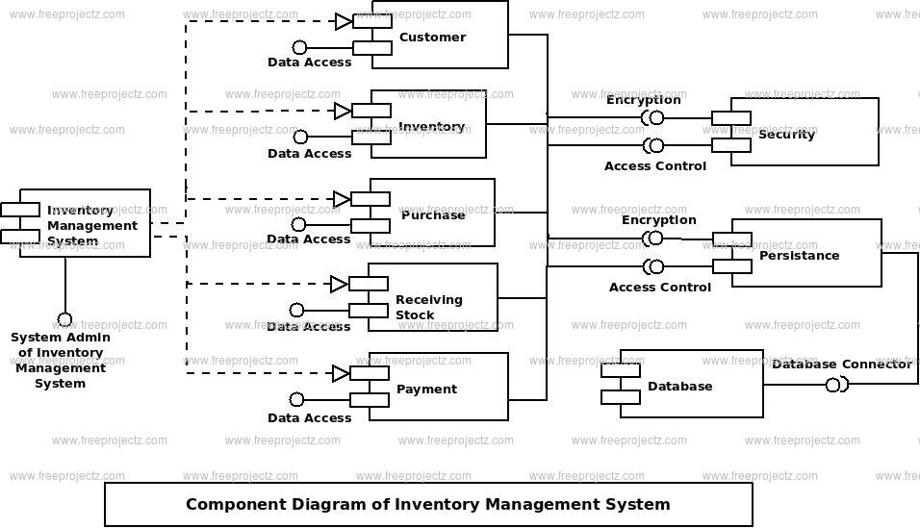

**Imaging system:**

Imaging systems can play a valuable role in various aspects of inventory management, offering significant benefits in accuracy, efficiency, and cost savings. Here are some key applications and considerations:

**Inventory Tracking and Counting:**

* **Automated product identification:** Barcode scanners and RFID tags provide automatic identification and data capture, eliminating manual counting errors and speeding up inventory checks.
* **Computer vision and object detection:** Cameras equipped with AI can automatically count items on shelves or pallets, reducing labor costs and increasing accuracy, especially for large, dynamic inventories.
* **Drone inventory management:** For warehouses with high shelves or uneven terrain, drones equipped with cameras can conduct automated inventory checks, covering large areas quickly and safely.

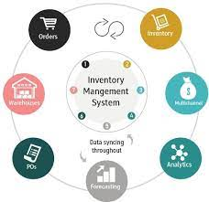

**Required Design for a Inventory management App:**

While specific designs vary, essential aspects to consider include:

* **User Interface (UI) Design:** 
  + User-friendly and intuitive navigation for browsing news articles.
  + Clean and readable layout for both text and multimedia content.
  + Personalization options like dark mode, font size adjustments, and saved preferences.
* **Back-End Design:**
  + Scalable and robust infrastructure to handle user traffic and data demands.
  + Secure authentication and authorization protocols for user accounts.
  + Efficient data storage and retrieval mechanisms for news content and user information.
  + APIs for interacting with external news sources and services.
* **Data & Content Management:**
  + Defined content hierarchy and tagging for efficient organization and searching.
  + Integration with content management systems (CMS) for content creation and editing.
  + Processes for content moderation and quality control.
* **Analytics & Personalization:**
  + User tracking and data analysis to understand user behavior and preferences.
  + Machine learning algorithms for personalized content recommendations and news feeds.
  + A/B testing to optimize design, features, and user experience.
* **Goods are delivered to your facility system**

**Facility and Goods:**

* **Facility type:** Warehouse, retail store, manufacturing plant, or something else?
* **Goods type:** Raw materials, finished products, or something else?

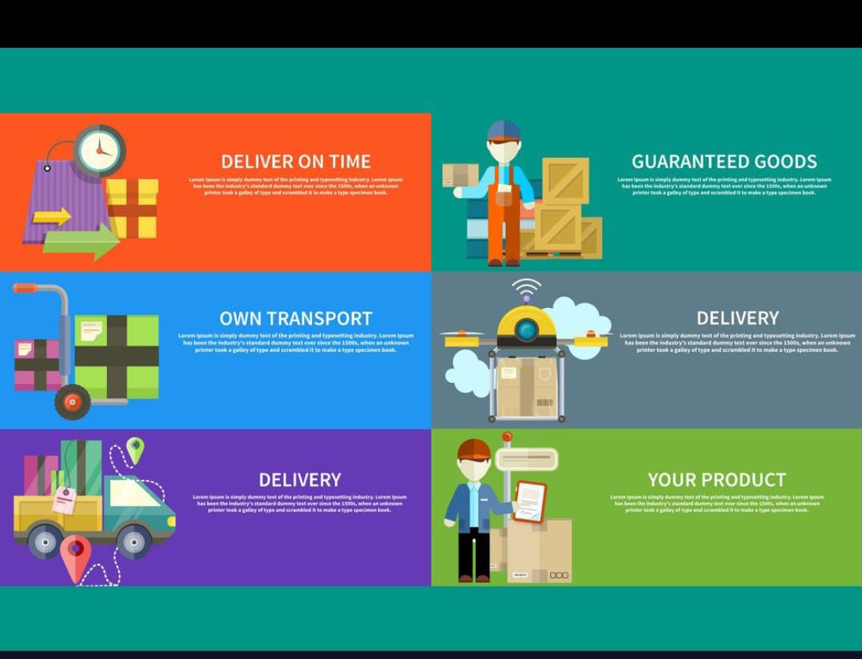

* **Inspect, sort and store goods.**

**Inspection Process:**

* **What are the key inspection criteria?** (Quality, damage, quantity, compliance with specifications, etc.)
* **What tools and equipment do you intend to use for inspection?** (Visual inspection, barcode scanners, specialized testing equipment, etc.)
* **Sorting and Storage:**
* **What are the sorting criteria?** (Product type, size, weight, demand, expiration date, etc.)
* **Do you have any specific storage requirements?** (Temperature control, humidity control, security measures, etc.)
* **What storage system are you considering?** (Pallet racking, shelving, bins, carousels, etc.)

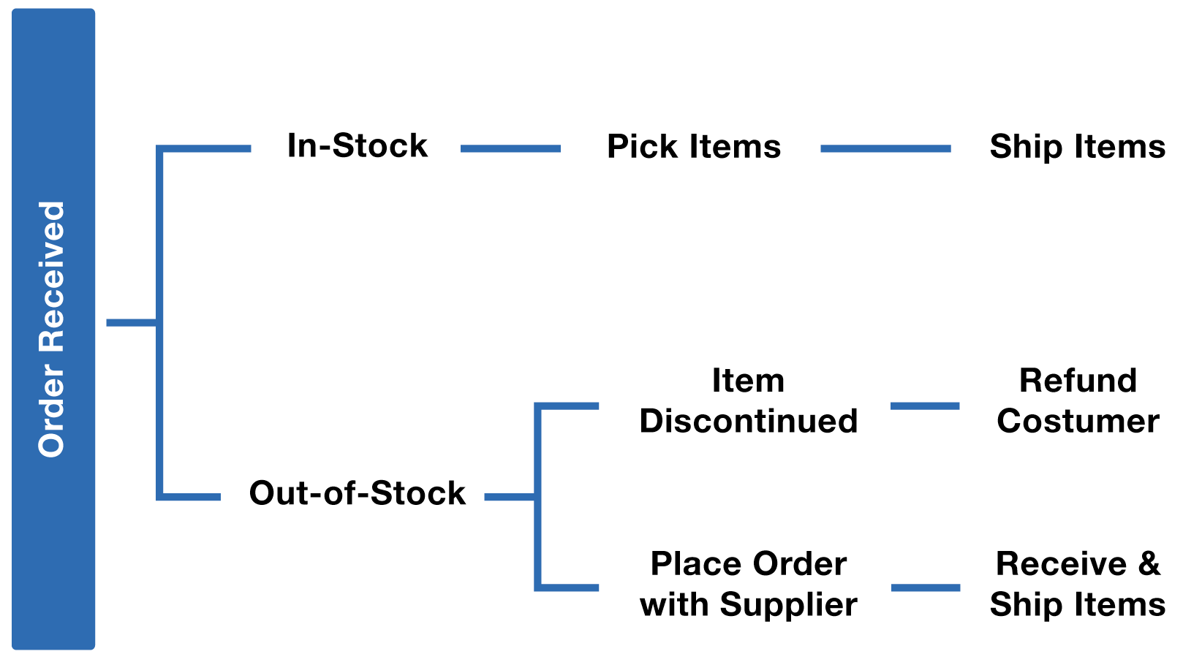

* **Stock orders are placed.**

In inventory management projects, stock orders, also known as purchase orders, serve as vital instruments for ensuring that the right items are acquired in the correct quantities at the most favourable terms. They play a pivotal role in optimizing inventory levels, minimizing costs, and fulfilling customer demand effectively.

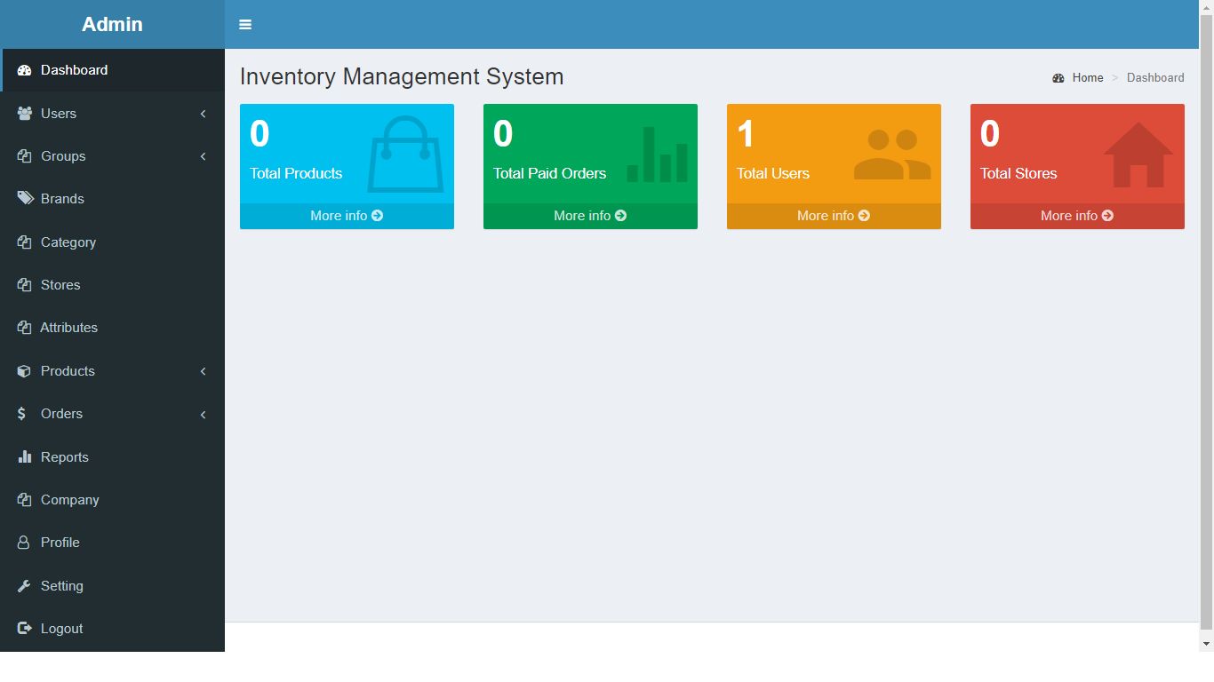

* **Stock orders are approved**

## This is when you pass the order to your supplier, or it may be automated through your POS system. Take goods from stock. The necessary goods are found by SKU number, taken from stock and shipped to the manufacturer or customer.

## 9,292 Approved Order Images, Stock Photos, 3D objects, & Vectors | Shutterstock

* **Take goods from stock**

## Stock-Taking Meaning | Purpose, Procedure, Methods & Format

1. **Order Generation:** An order triggers the picking process, often initiated by:
   * Sales orders
   * Production requirements
   * Internal transfers
   * Replenishment needs
2. **Picking Instruction:** A picking list or slip details the items, quantities, and locations within the warehouse.
3. **Picking:** Warehouse personnel physically locate and retrieve the specified items from designated storage areas.
4. **Checking:** The picked items are verified against the picking list for accuracy and completeness.
5. **Packing:** The picked items are packed according to order specifications or transfer requirements.
6. **Documentation:** Inventory levels are updated, and shipping or transfer documentation is generated.

**7. Construction or Fabrication details:**

**Purpose of your project:**

* Are you managing inventory for construction materials, fabricated components, or both?
* Is your project focused on a specific type of construction (e.g., residential, commercial)?
* What stage of the construction process are you focusing on (e.g., planning, execution, closeout)?

**Inventory Management Challenges:**

* What are your current pain points or inefficiencies in managing inventory?
* Are there specific materials or components causing challenges?
* Are you facing issues with tracking location, quantity, or condition of inventory?

**Desired outcomes:**

* What improvements do you expect from your inventory management project?
* Do you aim for increased efficiency, cost reduction, improved visibility, or other goals?
* Are there specific features or functionalities you need (e.g., real-time tracking, demand forecasting)?

**Project Constraints:**

* What are your budget limitations for implementing construction/fabrication solutions?
* Are there any space constraints for storing inventory on-site or off-site?
* Do you have any limitations regarding technology adoption or integration with existing systems?

Once I have a clearer understanding of your specific needs, I can guide you towards relevant solutions, including:

* **Construction-specific inventory management software:** Several software options offer features like material tracking, purchase orders, site tracking, and reporting, tailored to construction needs.
* **Modular/Prefabricated components:** Utilizing prefabricated components can reduce on-site inventory needs and streamline construction processes.
* **Just-in-time inventory management:** This approach minimizes on-site inventory by receiving materials only when needed, requiring efficient coordination with suppliers.
* **Inventory tracking technologies:** Technologies like RFID tags or barcode scanners can improve tracking accuracy and real-time visibility.
* **Warehouse optimization and layout:** Optimizing storage space and implementing efficient picking/packing processes can improve inventory management efficiency.

**8. Any other information needed to execute the capstone project:**

**1. Project Scope and Goals:**

* What is the size and complexity of the inventory you are managing?
* Are you focusing on a specific industry or type of inventory (e.g., retail, manufacturing, healthcare)?
* What are the core objectives or challenges you aim to address with your project? (e.g., improving accuracy, optimizing stock levels, reducing costs)

**2. Chosen System or Approach:**

* Are you developing a new inventory management system from scratch, or utilizing existing software/tools?
* If using existing tools, which specific platform or software have you chosen?
* Do you plan to integrate with any other systems (e.g., accounting, e-commerce)?

**3. Technical Requirements:**

* What programming languages or technologies are you familiar with or required to use?
* What are the hardware and software resources available for your project?
* Do you have any specific security or data privacy considerations?

**4. Deliverables and Evaluation:**

* What are the expected deliverables of your capstone project (e.g., functional system, report, presentation)?
* What are the key criteria for evaluating your project's success?

**Additional Information:**

* Any specific features or functionalities you want to implement in your project?
* Do you have any budget or timeline constraints?
* Are there any specific datasets or resources you plan to use?

Date :

1

2

3

4

Signature of the student: Signature of the cohort owner